Elementary Pro-Con Debate
Speaker Scripts
Version 5.0

Be Ready to Debate, Two Flowsheets Page 2
Speaking Times in Order Page 2

1st Pro Script Page 3
2nd Pro Script Page 4
3rd/4th Pro Script Page 5

1st Con Script Page 6
2nd Con Script Page 7
3rd/4th Con Script Page 8

Making and Responding to Arguments Page 9
Tips on Asking and Answering Questions Page 10
Practice and Examples of Questions Page 11

Be Ready to Debate!

BEFORE EACH AND EVERY DEBATE:
1. Pens ready!
2. Flowsheets ready
3. Script printed, ready to use/fill out
4. Review the Cases-Responses and/or Research the Topic.

Have your two flowsheets ready to go!
Pro Flowsheet Con Flowsheet
(for pro contentions and con (for con contentions and pro
responses to the pro contentions) responses to the con contentions)
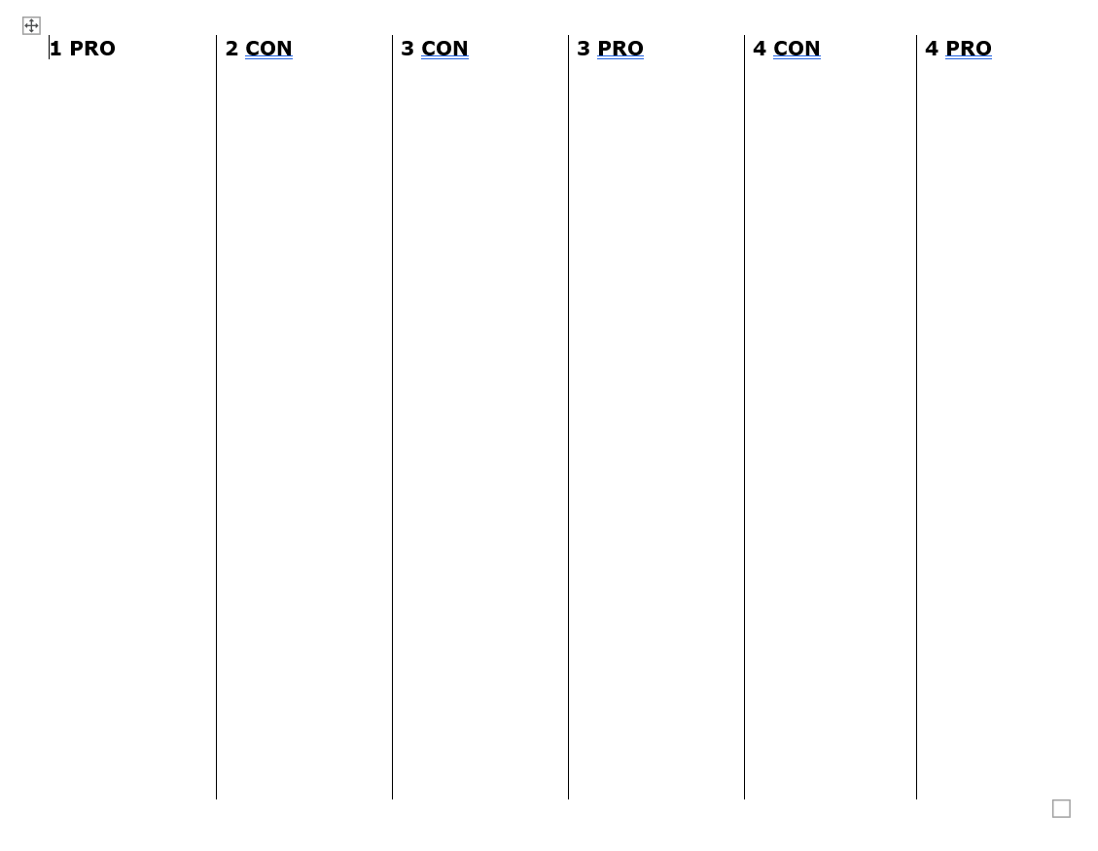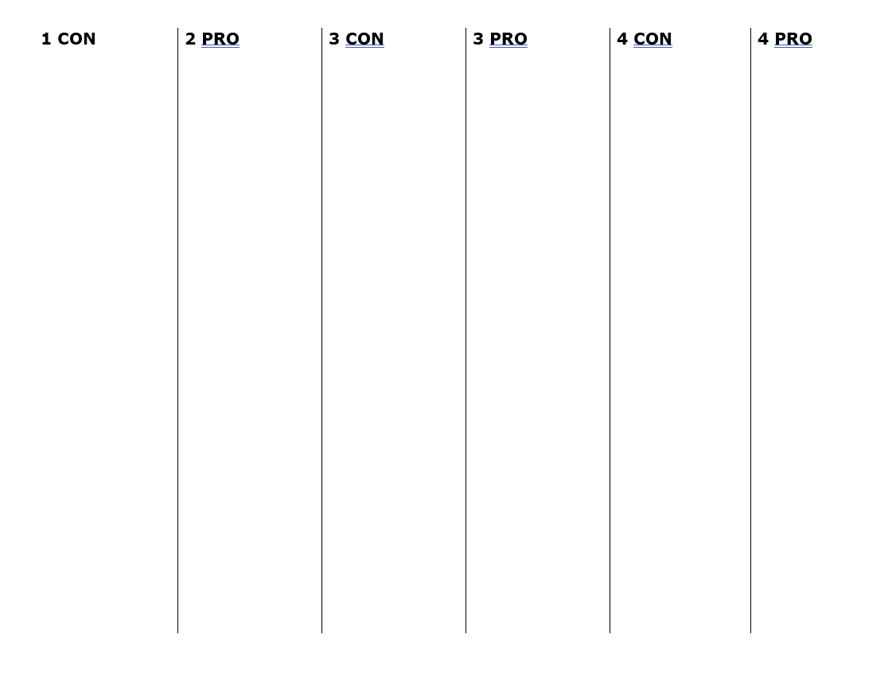

Elementary Pro-Con Debate Speech Order and Times

3 min. 1st Pro—present TWO pro contentions for the topic
3 min. 1st Con—present TWO con contentions against the topic
2 min. Question and Answer between 1st speakers

3 min. 2nd Con—respond to the pro contentions
3 min. 2nd Pro—respond to the con contentions
2 min. Question and Answer between 2nd speakers

3 min. 3rd Con—show you win the contentions in the debate
3 min. 3rd Pro—show you win the contentions in the debate
2 min. Question and Answer between 3rd speakers

If you have a 4th speaker on a team . . .
3 min. 4th Con—show you win the contentions in the debate
3 min. 4th Pro—show you win the contentions in the debate
2 min. Question and Answer between 4th speakers

45 sec. each speaker Weigh! Show why your arguments show you should win the debate.

1st Pro Speaker Script
SETUP YOUR FLOWSHEET AND PREFLOW YOUR CASE CONTENTION(S)

My name is ____________________________________________.

We want to solve (state the problem): _________________________________________
___________________________________________________________________

We are for the topic (state it EXACTLY THE WAY IT IS WORDED.)
___________________________________________________________________
In my speech, I will present two contentions, __________________________ and _________________________________

Our First Contention is ________USE YOUR FLOWSHEET__________
This is the Problem: The Topic will solve this problem: This is the impact:

Our Second Contention is ________USE YOUR FLOWSHEET__________
This is the Problem: The Topic will solve this problem: This is the impact:

Conclude: We urge you to vote for the Pro side.

After you speak, take notes of the arguments in the debate. Needed to do your Weigh!

After the 1st Con Speaker, ask and answer questions. Where did you prove __________?
Where did you show the impact to _______________________________?

After Question and Answer: Take more notes and help your partners with their speeches when it is helpful (you can pass them a clearly written note—but don’t interrupt them).

Weigh! After the last question and answer, state why you think you win the debate.

I believe we won because our argument ______________________________ is stronger than the con’s argument that ______________________________ because _______________________________________________________. USE YOUR FLOWSHEET.

2nd Pro Speaker Script
Prepare for your Speech Know your 1st speaker’s contentions. ON A SEPARATE SHEET--Write a list of contentions the Con might present. Write down responses against those contentions.
During the debate, flow the debaters—ESPECIALLY: listen to and briefly flow the 1st Con speaker’s contentions while you spend 90% of your time writing responses to the con’s contentions.

My name is _______________________________.

My partner showed (state the 1st Pro best arguments): ____________________
____________________________________________________________________

Against the Con’s First Contention that __USE YOUR FLOWSHEET_______

First, ___. Second, ___. Third, ____.
STATE YOUR RESPONSES USING YOUR FLOWSHEET. Give reasons for each response.

Against the Con’s Second Contention that __USE YOUR FLOWSHEET______

First, ___. Second, ___. Third, ____.
STATE YOUR RESPONSES USING YOUR FLOWSHEET. Give reasons for each response.

Conclude: We urge you to vote for the Pro side.

After you speak, take notes of the arguments in the debate. Needed to do your Weigh!

After your speech, ask and answer questions. Where did you prove _________?
Where did you show the impact to _______________________________?

After Question and Answer: Take more notes and help your partners with their speeches when it is helpful (you can pass them a clearly written note—but don’t interrupt them).

Weigh! After the last question and answer, state why you think you win the debate.

I believe we won because our argument ______________________________ is stronger than the con’s argument that ______________________________ because _______________________________________________________. USE YOUR FLOWSHEET.

3rd AND 4th Pro Speaker Script
Prepare for your Speech During Prep Time: Help with and know your 1st speaker’s contentions. Help the 2nd speaker prepare responses.
During the debate carefully flow—you need to use your partners’ arguments to win the debate!

IMPORTANT: YOU CAN’T MAKE NEW ARGUMENTS IN YOUR SPEECH—YOUR JOB IS TO SHOW BOTH OF YOUR PARTNER’S ARGUMENTS WERE THE BEST.

My name is _______________________________.

In my speech, I will show why we win each contention.

First, we showed in our Pro Contention 1 ___________________.
Explain why your partners beat the con’s responses to the contention.
USE YOUR FLOWSHEET

Second, we showed in our Pro Contention 2 __________________.
Explain why your partners beat the con’s responses to the contention.
USE YOUR FLOWSHEET

Third, we defeated the Con Contention 1 ___________________.
Explain why your partners beat the con’s contention.
USE YOUR FLOWSHEET

Fourth, we defeated the Con Contention 2 ___________________.
Explain why your partners beat the con’s contention.
USE YOUR FLOWSHEET

Conclude: We urge you to vote for the Pro side.

After you speak, ask and answer questions. Where did you prove _________________?
Where did you show the impact to _______________________________?

Weigh! After the last question and answer, state why you think you win the debate.

I believe we won because our argument ______________________________ is stronger than the con’s argument that ______________________________ because _______________________________________________________. USE YOUR FLOWSHEET.

1st Con Speaker Script
SETUP YOUR FLOWSHEET AND PREFLOW YOUR CASE CONTENTION(S)

My name is ________________________________________.

The Topic will cause this problem: _________________________________________
___________________________________________________________________
We are against the topic (state it EXACTLY THE WAY IT IS WORDED.)
___________________________________________________________________
In my speech, I will present two contentions, __________________________ and _________________________________

Our First Contention is ________USE YOUR FLOWSHEET__________
The Topic will cause this problem: This is the impact:

Our Second Contention is ________USE YOUR FLOWSHEET__________
The Topic will cause this problem: This is the impact:

Conclude: We urge you to vote for the Con side.

After you speak, take notes of the arguments in the debate. Needed to do your Weigh!

After you speak, ask and answer questions. Where did you prove __________?
Where did you show the impact to _______________________________?

After Question and Answer: Take more notes and help your partners with their speeches when it is helpful (you can pass them a clearly written note—but don’t interrupt them).

Weigh! After the last question and answer, state why you think you win the debate.

I believe we won because our argument ______________________________ is stronger than the con’s argument that ______________________________ because _______________________________________________________. USE YOUR FLOWSHEET.

2nd Con Speaker Script
Prepare for your Speech Know your 1st speaker’s contentions. ON A SEPARATE SHEET--Write a list of contentions the Pro might present. Write down responses against those contentions.
During the debate, flow the debaters—ESPECIALLY: listen to and briefly flow the 1st Con speaker’s contentions while you spend 90% of your time writing responses to the con’s contentions.

My name is _______________________________.

My partner showed (state the 1st Con best arguments): ____________________
____________________________________________________________________

Against the Pro’s First Contention that __USE YOUR FLOWSHEET_______

First, ___. Second, ___. Third, ____.
STATE YOUR RESPONSES USING YOUR FLOWSHEET. Give reasons for each response.

Against the Pro’s Second Contention that __USE YOUR FLOWSHEET______

First, ___. Second, ___. Third, ____.
STATE YOUR RESPONSES USING YOUR FLOWSHEET. Give reasons for each response.

Conclude: We urge you to vote for the Con side.

After you speak, take notes of the arguments in the debate. Needed to do your Weigh!

After your speech, ask and answer questions. Where did you prove _________?
Where did you show the impact to _______________________________?

After Question and Answer: Take more notes and help your partners with their speeches when it is helpful (you can pass them a clearly written note—but don’t interrupt them).

Weigh! After the last question and answer, state why you think you win the debate.

I believe we won because our argument ______________________________ is stronger than the con’s argument that ______________________________ because _______________________________________________________. USE YOUR FLOWSHEET.

3rd AND 4th Con Speaker Script
Prepare for your Speech During Prep Time: Help with and know your 1st speaker’s contentions. Help the 2nd speaker prepare responses.
During the debate carefully flow—you need to use your partners’ arguments to win the debate!

IMPORTANT: YOU CAN’T MAKE NEW ARGUMENTS IN YOUR SPEECH—YOUR JOB IS TO SHOW BOTH OF YOUR PARTNER’S ARGUMENTS WERE THE BEST.

My name is _______________________________.

In my speech, I will show why we win each contention.

First, we showed in our Con Contention 1 ___________________.
Explain why your partners beat the pro’s responses to the contention.
USE YOUR FLOWSHEET

Second, we showed in our Con Contention 2 __________________.
Explain why your partners beat the pro’s responses to the contention.
USE YOUR FLOWSHEET

Third, we defeated the Pro Contention 1 ___________________.
Explain why your partners beat the pro’s contention.
USE YOUR FLOWSHEET

Fourth, we defeated the Pro Contention 2 ___________________.
Explain why your partners beat the pro’s contention.
USE YOUR FLOWSHEET

Conclude: We urge you to vote for the Con side.

After you speak, ask and answer questions. Where did you prove _________________?
Where did you show the impact to _______________________________?

Weigh! After the last question and answer, state why you think you win the debate.

I believe we won because our argument ______________________________ is stronger than the con’s argument that ______________________________ because _______________________________________________________. USE YOUR FLOWSHEET.

Making and Responding to Arguments

ARGUMENT AREI

 | Topic: Schools should start later in the morning
A – Assertion  The main point of your argument | Starting schools later in the morning improves student learning
R – Reason  Why the argument is true  Because ________________ | Because students aren’t so tired
E – Evidence  Support for why the argument is true  Studies, statistics, expert opinion, facts | Recent UW study showed more sleep and better learning outcomes
I – Importance  the importance of the argument  So, __(this proves the argument)______  So, __(this proves the topic)______ | So, starting later does help learning.  Or  So we do need schools to start later to improve learning.

RESPONDING TO ARGUMENTS

State their argument in as few words as possible.  They said _________________ | They said starting schools later increases learning.
Respond.  Usually-state the opposite  X is not true.  Sometimes—state the argument isn’t important.  X is not that significant.  Sometimes—state your side is the best way to solve the issue.  We solve X better.  In a few cases, agree with their argument and show it proves your case.  X is true and that’s why we are right | Starting schools later does NOT increase learning because . . .  Or  Starting schools later does NOT increase learning significantly  Or  Our Sleep Education is the best way to increase learning because . . .  Or  We agree starting schools later increases learning and that’s why their proposal to start at 8:45am is NOT late enough!

Tips on Asking and Answering Questions

Begin Question and Answer by asking “May I have the first question” or “Do you want the first question.”
REALLY IMPORTANT—Try to ask as many questions as you can—while still giving your opponents the opportunity to respond. Taking control of the crossfire is a great way to win a debate.
ASKING  1. Face the judge—you are trying to convince the judge, not your opponent  2. Use a line of questioning—you said this, right? Doesn’t that mean x? If that is true, that shows y, right?  3. Avoid open ended questions that let your opponent answer with their own opinion or the ideas in their case.  NO! “Do you believe . . .?”  NO! “Don’t you think . . .?”  Such questions let your opponents say whatever they want to defend their side.  4. Ask questions that force them to defend what they said in their speech.  YES! ”Where did you show. . .?”  YES! “What proof did you provide for the argument . . .?”  Make them refer to or restate what they said in their speech—don’t let them state their opinion.  5. Be assertive but not aggressive. Don’t make personal attacks  6. Don’t be defensive. Try to show you are calm and collected even if you are nervous (which is common). | ANSWERING  1. Face the judge—you are trying to convince the judge, not your opponent  2. Do not pause before answering—try to answer right away—immediately.  Long pauses make it seem you don’t know your arguments well.  3. Don’t just answer yes-no—add on explanation. Get out of just responding to their questions—use their question as a chance to repeat key points in your case.  Example Question: “Your proposal would cost a lot of money, right.”  Example Answers:  NO! “Well, yes, but . . .”  NO! “No.” (no reason given)  YES! “No, it saves the economy money, lowers consumer costs, and is a good investment as our second contention showed.”  YES EVEN BETTER—KNOW YOUR SOURCES AND SPECIFIC DATA! “No, the Stevens study showed it saves the economy $2.3 billon, lowers consumer costs 3 to 7 percent, and is a good investment.”  4. Watch out for lines of questioning and where they are leading—avoid admitting things harmful to your case.  5a. If asked “what proof did you provide” try to respond with what you did show (avoid admitting that you did not provide proof)  Example Question: “What proof did you provide that your proposal is inexpensive?”  NO! “Well, you’re right, we did not prove that.”  YES “We have shown over and again that the proposal is a good investment that helps the economy and saves consumers money.”  5b. If they press further, say “Make that argument in your next speech and I will respond” (allowing you to respond and to not admit you failed to prove an argument).  6. Don’t be defensive. Try to show you are calm and collected even if you are nervous (which is common).

Practice and Examples of Questions

Practice!
--with another debater (or several other debaters), ask questions and answer questions about your cases and your rebuttals.
--maybe ask your parent(s)/guardians questions about the death penalty.
--think of a flawed argument—a weak argument with poor support. Now, ask a question about it.
--read a short article or short section of an article about the death penalty and ask a question about it to yourself.

Examples of questions to ask:

--ask them about missing proofs
Where did you prove ______________?
Eg Where did you show anyone after 2000 and DNA tests has someone been wrongly convicted of a crime?

--ask them about arguments against their case to see how they will respond
Eg How is it moral to kill someone to show that killing is wrong?
Eg Won’t removing the death penalty just mean dangerous prisoners will be left in jail?

--ask them to compare arguments
Eg Where did you show deterrence is more important than racism and killing innocent people?
--ask to point out contradictions
Eg You said vengeance is good but then you also said life imprisonment is cruel. Isn’t that a contradiction—I mean if life imprisonment is cruel—doesn’t that satisfy your belief in vengeance?

--ask them to explain their evidence/arguments
Eg How did they conclude 4.5 times as many African Americans were given the death penalty? Did they consider the type of crimes?
--ask them about their conclusions
Eg Do you really think we should kill people because it might lead other people to be deterred from killing?
Eg You’ve claimed several innocent people might have been executed in the past. Does that really mean we should end the death penalty today?

